AI-ESM App Documentation
Architecture, code structure, module responsibilities, and command-line usage demo for the current orchestration layer.
This document explains the current AI-ESM app layer. The app is an MVP orchestration layer around an existing capacity expansion runner. It validates scenario inputs, launches the model, analyzes solver logs and outputs, triggers refinement recommendations, optionally applies safe solver-setting patches, and records iteration memory.

1. Architecture overview
The app is organized as a deterministic pipeline. Research intent is converted into a scenario configuration, the solver is launched, diagnostics are collected, and the controller decides whether to stop, recommend a fix, or rerun with a safe patch.
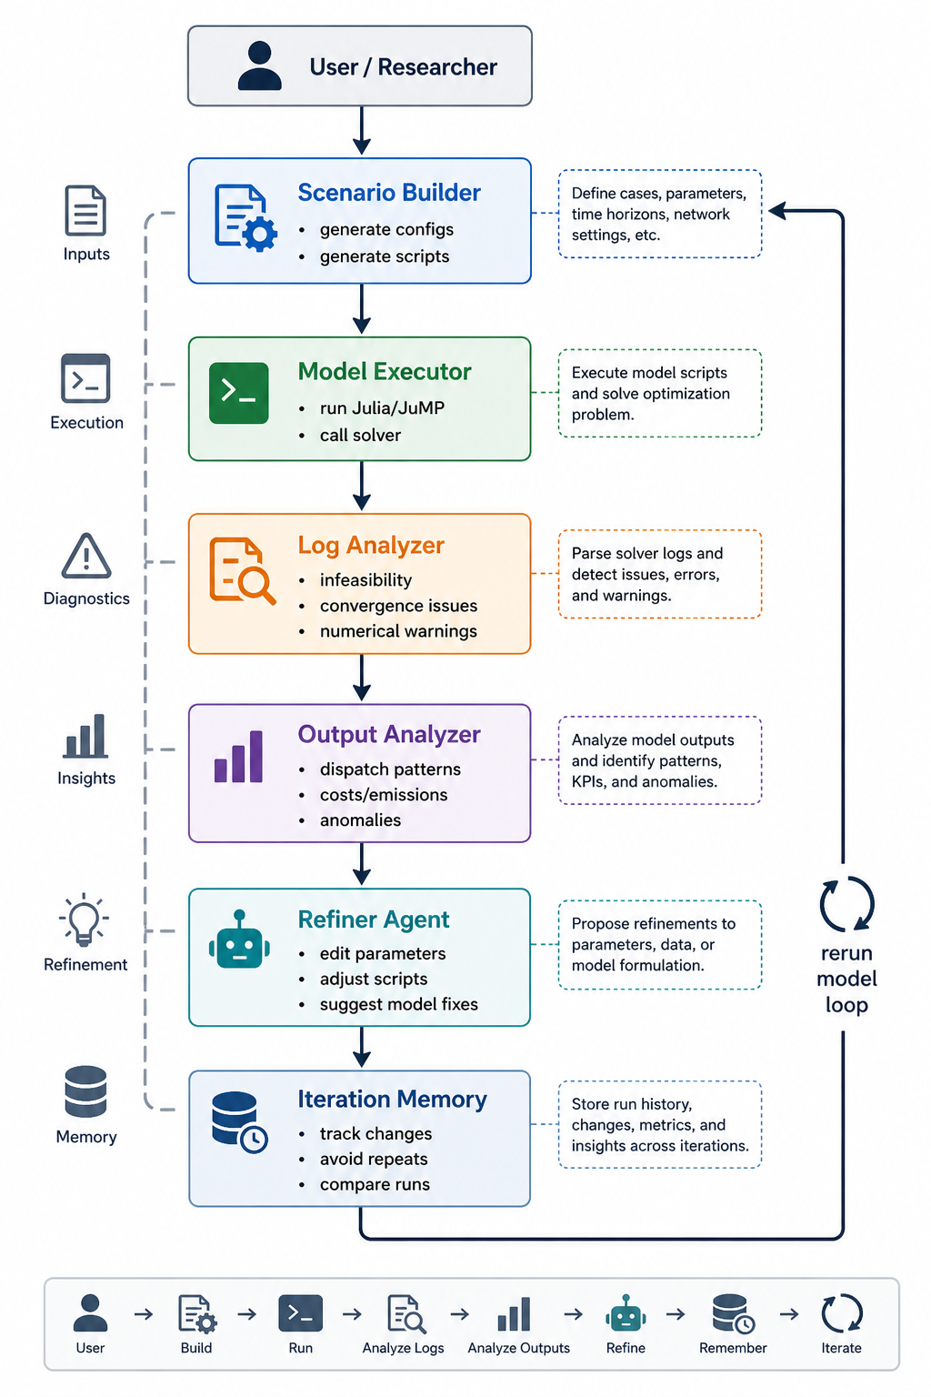
Figure 1. AI-ESM pipeline architecture from Pipeline.png.

2. Current workflow
- VALIDATE_SCENARIO: check scenario identifiers, input data files, demand horizon, candidate generators, solver settings, and expected output paths.
- LAUNCH_SOLVER: run the configured capacity expansion backend as a subprocess and capture stdout, stderr, return code, elapsed time, and solve summary.
- ANALYZE_SOLVER_LOG: classify solver-side status using the configured log file when available, with fallback to captured stdout/stderr and solve summary.
- ANALYZE_OUTPUTS: check physical and economic plausibility after a completed solve.
- TRIGGER_REFINER: map non-OK diagnostics into recommendation-only next actions or safe solver-setting overrides.
- SAFE_PATCH_AND_RERUN: when allowed by budget and policy, create a patched iteration config and rerun.
- ITERATION_MEMORY_APPEND: append a compact record to runs/run_history.jsonl and embed memory summary in run_state.json.

3. Code structure
File | Purpose | Main functions/responsibilities
agent/orchestrator.py | CLI entrypoint and controller loop. | Defines run state, controller decisions, validation/execution/analyzer/refiner sequencing, safe rerun handling, final persistence, and history display.
agent/validation.py | Pre-solve scenario validator. | Checks required scenario identifiers, input files, CSV columns, expected hour counts, candidate generator filters, solver settings, and expected outputs.
agent/solver_log_analysis.py | Solver log parser and classifier. | Loads configured logs or stdout/stderr fallback, detects termination status, infeasibility, numerical issues, convergence, and performance metrics.
agent/output_analysis.py | Post-solve output quality checker. | Checks solve summary consistency, output files, capacity nonnegativity, hourly power balance, capacity limits, and non-served energy severity.
agent/refiner.py | Diagnostic-to-recommendation mapper. | Chooses primary issue, returns STOP, CONTINUE, or RESTRUCTURE guidance, and proposes safe solver-setting overrides or recommendation-only fixes.
agent/scenario_patching.py | Safe rerun patcher. | Applies a deliberately narrow solver_settings patch boundary and redirects iteration output paths into run-specific folders.
agent/iteration_memory.py | Append-only run memory. | Builds compact history records, writes run_history.jsonl, summarizes best run, convergence, repeated causes, failure patterns, and plateau detection.
agent/__init__.py | Package marker. | Makes the orchestration layer importable as the agent package.

4. Run-state contract
Each run writes runs/<run_id>/run_state.json. This file is the main audit artifact for the workflow.
Run-state field | Description
controller_decisions | Ordered controller actions and routing decisions.
validation_results | Scenario validation status, checks, resolved input files, and matched candidate generators.
executor_results | Subprocess command, stdout/stderr logs, return code, elapsed time, and solve summary.
solver_log_analysis_results | Solver status, infeasibility or numerical diagnostics, and parsed performance metrics.
output_analysis_results | Physical and economic output checks, anomalies, warnings, and computed metrics.
refinement_results | Recommendation-only fixes or review actions triggered by diagnostics.
patch_results | Safe config patch attempts, applied/skipped overrides, and generated config path.
iteration_config_paths | Scenario config path used for each iteration.
memory_record and memory_summary | Compact run history entry plus summary of best run, convergence trend, repeated causes, and known failure patterns.

5. Controlled rerun policy
Reruns are intentionally conservative. They require an available iteration budget and a refiner recommendation to continue with supported safe overrides.
- Allowed automatic patches: solver_settings.time_limit_seconds, solver_settings.relative_mip_gap, solver_settings.presolve, solver_settings.log_to_console, and solver_settings.log_file.
- Skipped unsupported solver hints: warm_start, NumericFocus, and ScaleFlag.
- Blocked changes: policy constraints, generator changes, demand changes, structural changes, and model reformulations.

6. App usage demo
Run these commands from the repository root in PowerShell.
Run the current capacity expansion smoke scenario:
python -m agent.orchestrator run --config test\capacity_expansion_test_1\test_scenario_1_output.yaml --run-id orchestration_smoke_test
Allow a controlled rerun budget:
python -m agent.orchestrator run --config test\capacity_expansion_test_1\test_scenario_1_output.yaml --run-id controlled_rerun_smoke --max-iterations 2
Explicitly allow safe reruns:
python -m agent.orchestrator run --config test\capacity_expansion_test_1\test_scenario_1_output.yaml --run-id safe_rerun_test --max-iterations 2 --enable-reruns
View accumulated history:
python -m agent.orchestrator history
Compile-check agent modules:
python -m py_compile agent\orchestrator.py agent\validation.py agent\output_analysis.py agent\solver_log_analysis.py agent\refiner.py agent\iteration_memory.py agent\scenario_patching.py

7. Current smoke result
Metric | Value
Final status | COMPLETED
Solver status | OPTIMAL
Objective | 990,873,978.80 USD
Max power-balance imbalance | 0.0 MWh
Max capacity violation | 0.0 MWh
Total non-served energy | 637.0 MWh
NSE fraction of demand | 0.0028%
Refiner recommendation | STOP / NO_FIX

Because the refiner recommends STOP for the current smoke scenario, increasing --max-iterations does not trigger a rerun. That is expected behavior.

8. Development notes and next steps
- The current Python backend does not write the configured HiGHS log path, so solver-log analysis falls back to captured stdout/stderr for that backend.
- The Julia test case includes a real HiGHS log, and the parser can extract model size, simplex iterations, runtime, and objective from it.
- If test runs become noisy, archive or reset runs/run_history.jsonl before a fresh demonstration run.
- Before expanding policy or structural patching, add focused tests for validation, output analysis, solver-log analysis, refiner rules, scenario patching, and memory.

Sources
- README.md
- agent/README.md
- doc/Agent Workflow Guide.md
- Pipeline.png
- agent/*.py function definitions

